Virtual Public Informational Meeting

NY Route 430 (Washington Street) and NY Route 394 (Fairmount Avenue)

Mill and Overlay, Road Diet, and ADA Improvements
Project Identification Number - 5814.36

NY Route 430 (Washington Street) Location Map
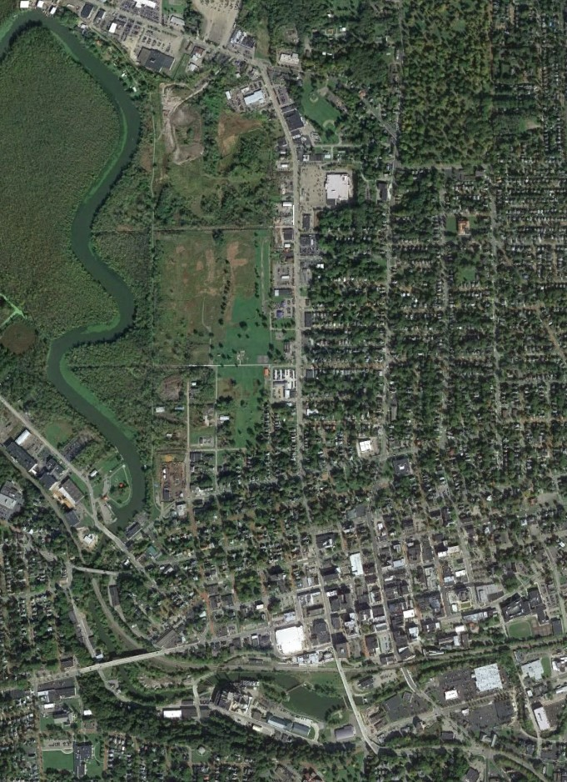
N
Fluvanna Avenue
Chadakoin
River

End Project Limit

Tops Friendly
Markets, Inc.

Chadakoin
park

11th Street

NY Route 430
(Washington Street)

E. 6th Street

Fairmount
Avenue

E. 2nd Street

Begin Project Limit

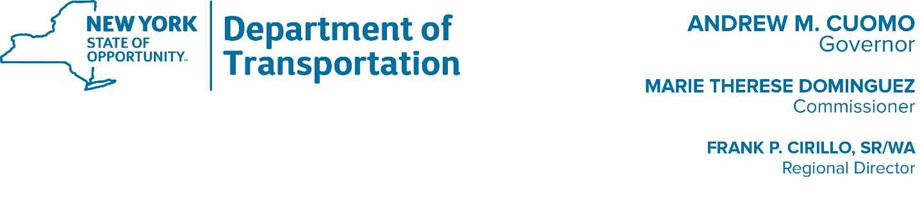
Copyright: Google Earth 2019

CITY OF JAMESTOWN, CHAUTAUQUA COUNTY

January 25, 2021

NY Route 394 (Fairmount Avenue) Location Map
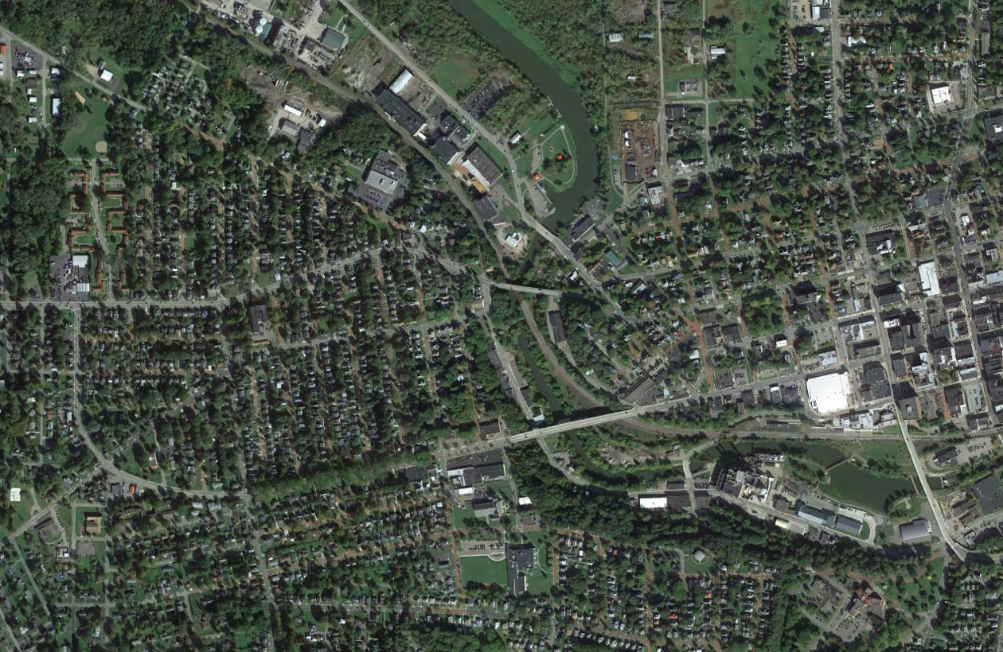

Chadakoin
N
River

Begin Project Limit

End Project Limit

W 5th Street
Washington Street

McDaniel
NY Route 394
(Fairmount Avenue)

3rd Street

Avenue

Copyright: Google Earth 2019

CITY OF JAMESTOWN, CHAUTAUQUA COUNTY

SCHEDULE
6:45 PM – 7:15 PM | VIRTUAL OPEN HOUSE – PRESENTATION & QUESTIONS / ANSWERS

PLEASE NOTE

All formal comments made and/or received during this public information meeting on the NY Route 430 (Washington Street) and NY Route 394 (Fairmount Avenue) rehabilitation project and all written documents filed with the New York State Department of Transportation (NYSDOT) by February 8, 2021 will be considered and will receive careful consideration in future decisions on the project. Comments can be presented to the Department by printing the “Comment Sheet” available on the City Jamestown website and mailing the Comment Sheet to:

Frank P. Cirillo, SR/WA, Regional Director
Attention: Sanjay Singh, P.E.

New York State Department of Transportation
100 Seneca Street
Buffalo, New York 14203

Alternatively, comments can be sent electronically at the following link:
https://www.dot.ny.gov/portal/pls/portal/MEXIS_APP.DYN_PROJECT_DETAILS.show?p_arg_names=p_pin&p_arg_values=581436#a_contact

PROJECT DESCRIPTION

The proposed project is located on NY Route 430 (Washington Street) and extends from Fluvanna Avenue to Second Street and NY Route 394 (Fairmont Avenue) from the City of Jamestown west city line to West Fifth Street within the City of Jamestown, Chautauqua County.

Further information on this project is available for inspection and copying at:

New York State Department of Transportation
100 Seneca Street
Buffalo, New York 14203

BACKGROUND

The existing pavement on NY Route 430 (Washington Street) and NY Route 394 (Fairmount Avenue) is exhibiting general alligator cracking and potholes are present throughout. The existing pavement surface has reached the end of its useful service life. The project proposes to improve the riding surface through milling and resurfacing the existing pavement. It will also address pedestrian and bicycle accommodations which are lacking within the project limits and bring current sidewalk ramps into compliance with current ADA Standards.

In concert with the above improvements to NY Route 430 (Washington Street), the existing four lane roadway section on Washington Street between Fluvanna Avenue to West Second Street has been evaluated for reconfiguration to a three-lane roadway section to increase driver safety while also increasing pedestrian and bicyclist safety and mobility.

Driver safety in this highway segment will be increased through the addition of a two-way left turn lane while better accommodating pedestrians through high visibility crosswalks and additional sidewalk connectivity and upgraded curb ramps. Bicycle safety will be increased on Washington Street through addition of 5’ bike lanes with 2’ buffer lane in both directions. Traffic signals along both Washington Street and Fairmount Avenue will be replaced/modified. Milling and paving is proposed on Fairmount Avenue along with ADA improvements. The lane configuration on Fairmount Avenue will remain the same.

Average Daily Traffic (ADT) - Washington Street - 12,025 (2017)
Average Daily Traffic (ADT) – Fairmont Avenue - 15,104 (2017)
PROJECT OBJECTIVES

- Improve overall traffic conditions using cost effective methods to reduce delay and to provide an acceptable level of service, for a design period of 10 years.
- Correct identified pavement deficiencies that will extend the useful life of the highway and maintain it in a structurally sound condition using cost effective pavement treatments which provide low life cycle costs.
- Upgrade and improve pedestrian and bicyclist facilities within the project limits.
- Address drainage deficiencies (cleaning, drainage structure repairs) associated with the closed drainage system.

DESIGN ALTERNATIVES
Three (3) alternatives have been developed and considered for the project. They are:

Alternative 1 – No Build

Alternative 2 – Mill and Resurface with ADA Improvements while maintaining existing lane configuration for both NY Route 430 (Washington Street) and NY Route 394 (Fairmount Avenue). In addition to the above, the alternative would replace/modify eleven (11) Traffic signals along both Washington Street and Fairmount Avenue, replace all signage, place new striping, and correct drainage deficiencies associated with the closed drainage system by cleaning and drainage structure repairs.
Alternative 3 – Mill and Resurface with ADA Improvements along with a 4-lane to 3-lane ‘Road Diet’ conversion of NY Route 430 (Washington Street) from Fluvanna Avenue to West 2nd (Second) Street while maintaining the same lane configuration on Fairmount Avenue. This configuration would result in the creation of a two-way left-turn lane along with new 5’ bike lanes with 2’ buffer on along both sides on Washington Street.

In addition to the above, the alternative would replace/modify eleven (11) Traffic signals along both Washington Street and Fairmount Avenue, replace all signage, place new striping, and correct drainage deficiencies associated with the closed drainage system by cleaning and drainage structure repairs.
PREFERRED ALTERNATIVE

Alternative 3 has been selected as the Preferred Alternative

ALTERNATIVES COST
(1) Alternative 1 - $ 0
(2) Alternative 2 - $ 4,159,000
(3) Alternative 3 - $ 4,209,000
TENTATIVE PROJECT SCHEDULE, COSTS AND FUNDING

Obtain Design Approval: Spring 2021
Final Design Complete: Summer 2021
Anticipated Bid Opening: Fall 2021
Anticipated Construction Completion: Fall 2022

Current approved construction cost is $4,209,000 and will be Federally funded.

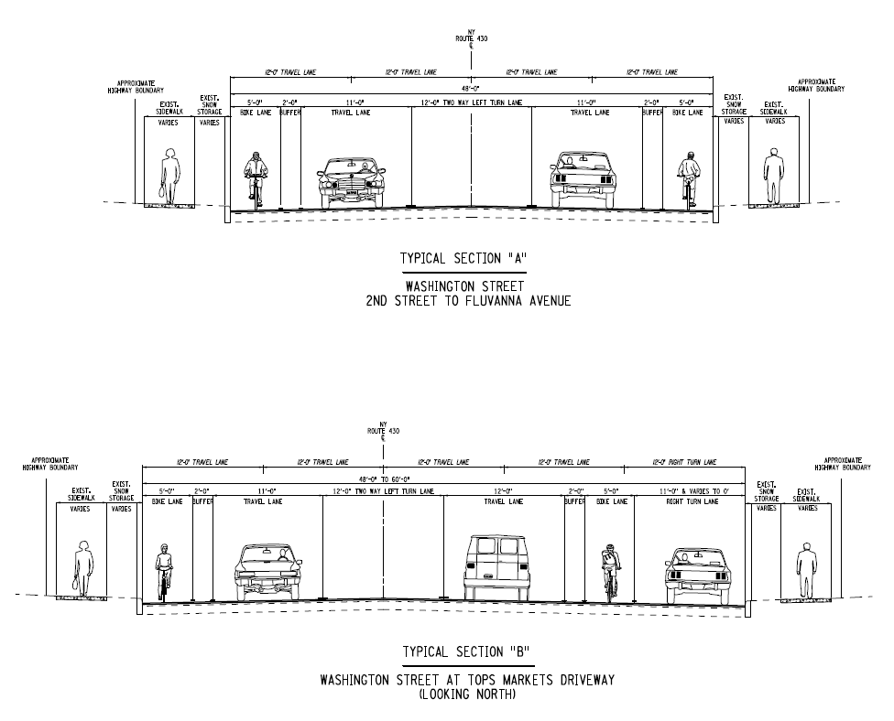
Alternative 3 – Typical Sections
Washington Street
Typical Sections for NY Route 430 and 60 (Washington Street)
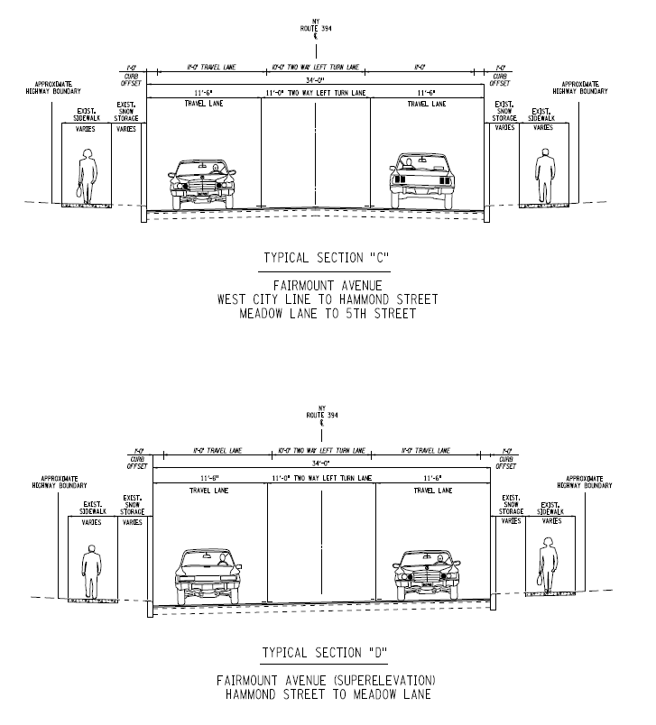
Alterative 3 – Typical Sections
Fairmont Avenue
Typical Sections for NY Route 394 (Fairmount Avenue)

